Birkenhead Camperdown Street Chapel
Part of the cover of the Camperdown Street PM
Trustees Minutes Book, 1855-1868
Camperdown Street (originally called Chapel Street East) is a side street off Hamilton Street between Duncan Street and Market Street, about 50m south of the south-east corner of Hamilton Square. The chapel has been identified with some confidence (despite not being labelled) on an 1876 map (see sketch map later); its site is now part of the backyard of no. 22 Market Street, one of the two houses that make up The Hornblowers pub.
I have not found a definitive history of this chapel and its society. What follows is what I have pieced together from numerous sources.
The Camperdown Street PM Society
A 1923 booklet refers to an 1849 Preaching Plan for Liverpool Circuit which showed societies in Prescot, Lime Kiln Lane (Vauxhall), Bootle and Garston on the Liverpool side, and Birkenhead, Liscard and Wallasey on Wirral. There were two early Birkenhead societies, one at the west end of the town (Beckwith Street) and the other at the east end of the town (Camperdown Street). The story of the Beckwith Street society’s history can be found here. The first Beckwith Street chapel was built sometime before 1850 and is believed to have been on the south side of the street; it disappeared from the records in the mid-1870s. A new chapel was built in 1880 on the north side of the street on the site of what had been no. 60. This chapel continued in use at least until 1914 when it was listed in Kelly’s Directory p. 82.
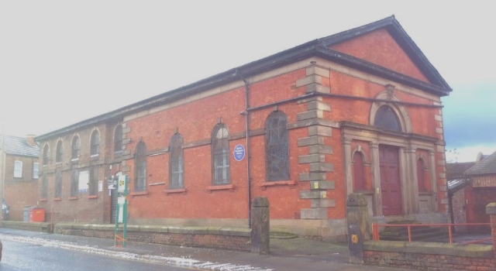
The first record I have found to date of a Camperdown PM society is in a fascinating document held in the Cheshire Archives and Local Studies in Chester: ‘Camperdown Street Trustees Minutes (P. M.) 1855 - 1868’ (unfortunately the preceding and following Minutes no longer exist). The society must have formed some time before 1855, probably meeting in people’s houses and hired meeting rooms. According to these Minutes, on Good Friday 6 April 1855 a Tea Meeting was held for 300 people (a substantial society!) in the Friends Meeting House in Hemingford Street. In September that year they agreed to rent the Friends Meeting House for £40 per annum, presumably to provide meeting space until the society had its own chapel. The Meeting House had been built in 1854 and consisted of a ‘House’ seating 200 and meeting rooms. In 1890 the building was sold to Charles Thompson and he opened a Mission to help the homeless and deprived with food, clothing and other support – the building still exists and its work continues today.
Friends Meeting House, Hemingford Street, Birkenhead (now Charles Thompson Mission)
In April 1855 the trustees decided to look for some land to build a new chapel. They set about raising money, settled on land in Camden Street west of the town centre and, in May 1857, invited five builders to submit estimates. However, a year later the Welsh Calvinist Methodist chapel in Camperdown Street came on the market and they decided to give up this land and to make an offer of £550 for the chapel. In July 1859 they obtained a £350 mortgage and met in the new chapel the following evening. Opening services were held on 18 and 25 September 1859. Rental for seats and pews were set at 1/3 per quarter for those in the body of the chapel and 1/- for those in the gallery.
Extract from the Camperdown Street PM Trustees Minutes,
27 July 1858
The 1859 Q2 Preaching Plan for the Liverpool Circuit showed that the circuit had a Birkenhead Branch that consisted of eight ‘Places’: Birkenhead [location not given], Liscard, South Tranmere, Poulton, Bebington, Hoylake Open Air, Greasby and Irby. The Branch Superintendent was Rev W. Wilkinson who lived at 190 Beckwith Street, suggesting that Beckwith Street was the ‘head’ chapel at that time. Birkenhead became an independent circuit later that year.
However, the Minutes Book after 1862 contains numerous references to decisions made by the Camperdown Street trustees about the Beckwith Street chapel; here are some:
- (1862) That we purchase the school room in Beckwith Street.
- (1862) That the sittings in Beckwith Street be let at 1/- per quarter.
- (1862) Susan Newton have liberty to teach in Day School in Beckwith Street school room.
- (1864) That Mr Hedge be the treasurer for Beckwith St.
- (1864) Request to hire the Beckwith Street room ‘if the morality of the songs is satisfactory.’ 1/- per night.
- (1865) Request to preach the Beckwith Street sermon on 16 April.
- (1866) That the school rent for Beckwith Street in future be £13 per annum. That a collection be made at Beckwith Street quarterly on behalf of the trustees.
- (1866) That it is not advisable at present to enlarge Beckwith Street as we contemplate building a new chapel.
- (1868) That we have a meeting with the Beckwith Street Society on Wednesday evening at ½ past 7 o’clock to lay before them the finances of the chapel.
These extracts suggest that, after 1862, the Camperdown Street Trustees were also responsible for Beckwith Street.
The 1869 Q3 Preaching Plan for the Birkenhead Circuit (a copy of which was put in a time capsule under the foundation stone of Grange Lane chapel) showed the following Places: Camperdown Street (by implication the head of the circuit), South Tranmere, Lower Tranmere, Beckwith Street, Poulton, Bebington, Seacombe and Saughall. There were two Sunday services at Camperdown Street, at 10.30 and 6, most of which were led by one or other of the two circuit ministers, Rev T Swallow and Rev W Thornley. There were also weekly Tuesday evening meetings and Saturday evening Band Meetings, and fortnightly Leaders’ Meeting and Circuit Committee. The ‘Renewal of Tickets’ table shows that Camperdown Street had seven classes, Lower Tranmere three and the remaining chapels either two or one. For a description of PM Classes see here.
The chapel building
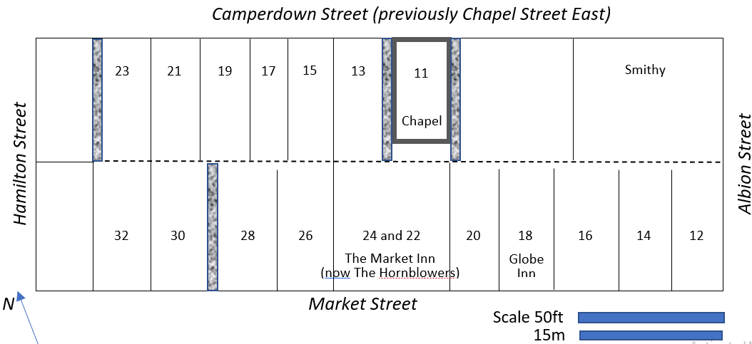
Sketch Map based on the 1876 1:500 map
This chapel was built in 1837 by a Welsh Calvinist society and was described in Kelly’s 1850 directory as ‘a small brick fabric’. There is no relevant entry in the 1841 Census but the 1851 Census shows that the street was then called Chapel Street (East). The ‘East’ was to distinguish it from Chapel Street, a street to the west of Hamilton Square and in no way connected to Chapel Street (East). Surely the ‘Chapel’ name refers to the Welsh Chapel. There were then 12 occupied properties (un-numbered) in the street containing 19 households and a total of 92 occupants, but no mention of the chapel (there was no requirement for the enumerator to record unoccupied buildings, although some did record chapels). The heads of household were variously:
Hairdresser, labourer, paviour, shipwright, mariner (2), bricklayer (5), Greenwich Pensioner, wire drawer, police officer, porter, letter carrier, moulder and warehouseman.
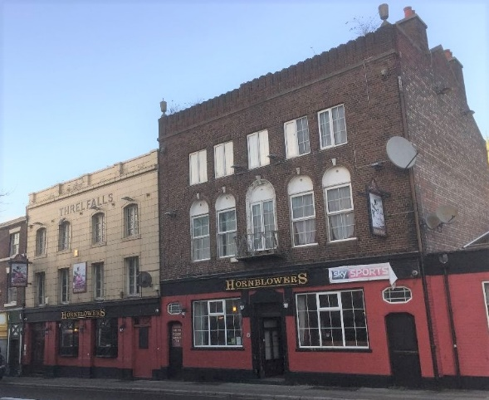
The 1861 census shows that the street name had by then been changed from Chapel Street (East) to Camperdown Street, a name that may come from a famous naval battle of 1797 when the British North Sea Fleet decisively beat a Dutch fleet. Relating the 1876 map to the sequence of the 1861 census we can deduce that the even numbers were on the north side of the street with no. 2 at the east end and no. 18 at the west, and the odd numbers were on the south side street running east to west starting with no. 5 (nos. 1 and 3 not listed) and ending with no. 13. No. 11 is shown (despite being unoccupied) as ‘Primitive Chapel’. Now looking at the 1871 census, the only occupied properties on the south side were nos. 9, 13, 15, 17, 19 and 23, ie, nos. 1-7, 11 and 21 were not listed. The most westerly property in the street, no. 23, is the only building which still exists today, surviving from the 1870s; the current owner confirms that its correct address is no. 23 Camperdown Street. Counting eastwards from this building on the 1876 map, we come to no. 11 which is shown as having alleys down each side, ie, it was a self-standing building not attached to the terraced houses on each side, probably so that light could reach the chapel’s side windows. This is consistent with the chapel having been built in 1837 but the houses not until the 1860s.
The chapel had a footprint of about 18 feet frontage x 35 feet deep and it would have seated about 100 (downstairs and in the gallery). It backed onto The Market Inn in Market Street (see sketch map above) opposite the Market Square; the market opened in 1845 and the Inn was built some time before 1850. The Inn still exists as The Hornblowers and the chapel site is part of its backyard.
The Hornblowers pub, previously The Market Inn (c. 1845), onto which the Camperdown Street chapel backed
Presumably the Camperdown Street chapel was sold after the Grange Lane chapel opened in 1870. I have not found any reference to the chapel being used by any other denomination. No later censuses list no. 11 either as a chapel or having occupants, and no directories show businesses at that address. Later maps up to 1925 show a building having the same or similar footprint on the site of the chapel – was it derelict or perhaps being used for storage?
By the time of a 1936 map, there was no building on the site; it was probably demolished because the newly built Queensway Road Tunnel passed only a few feet below.
The Society’s transition to Grange Lane
In February 1862, two and a half years after the opening of the Camperdown Street chapel, there is the first mention in the Minutes of a ‘proposed new chapel’ (that was to become the Grange Lane chapel). In September 1867 the trustees decided to seek ‘permission [from the Methodist church?] to dispose of the property [presumably the Camperdown Street chapel] now held by us in Birkenhead’.
In July 1869, before the laying of the foundation stone for the new Grange Lane PM chapel, members of the Camperdown Street Chapel processed from their chapel to the site of the new chapel, presumably symbolising the transition of their place of worship.
Definitive references to the Camperdown Street chapel
- 1837: the National Library of Wales holds archives on the Calvinist chapel. The heading is ‘Parkfield Welsh Calvinist Chapel, Birkenhead, Camperdown Street until 1859’; there are three accounts books:
  - Account book (Camperdown Street pew rents, weekly collections and ledger), 1837-1843
  - Receipt book, 1838-1843
  - Account book, 1847-1859.
- 1850: Kelly’s Directory (p. 678) describes ‘The Welsh Calvinistic Methodist Chapel situated in Chapel street East, is a small brick fabric erected in 1837.’
- 1857: the Post Office Directory introduction to Birkenhead (p. 21) lists non-conformist places of worship including ‘a Calvanistic Welsh Methodist Chapel in Chapel-street-east’. In the Street Directory there are no entries for tradesmen in Chapel Street East but the street is mentioned as being a side road between Nos. 37 and 39 Hamilton Street.
- 1858: the Cheshire Archives have a file of documents under the heading ‘Birkenhead, Grange Road Methodist Chapel’: ‘Opened in 1858 at Camperdown Street by the Primitive Methodists in a former Welsh Calvinistic Chapel, replacing temporary premises rented from the Society of Friends since 1855. Rebuilt at the corner of Grange Road and Beckwith Street [?] in 1870.’
- 1861: the Census contains the entry: no. 11 Camperdown Street, ‘Primitive Chapel’.
- 1866: a ‘Sketch’ of Henry Edward Judson J.P. (1850-1920) tell us that he was ‘a capable local preacher’ and Circuit Steward: ‘At the age of sixteen [in about 1866] he was persuaded by the appointed preacher at the Camperdown Street Church to assist in the service, but did not understand until he was actually called upon that he was expected to “Say a few words’”. After he had recovered from his surprise, and warmed to the theme he had immediately to decide upon, he gave abundant proof of fine preaching talent.’ Therefore at that time the Camperdown Street chapel was on the Preaching Plan.
- 1867: the Liverpool Mercury of 3 Jan reported on a marriage at Camperdown Street chapel:
HODGE – PRICE – Jan. 1, at the Primitive Methodist Chapel, Camperdown-street, Birkenhead, by the Rev. T. Hindley, assisted by the Rev. J. Hill, Mr. George Hodge, of Birkenhead, to Jane Price, of Seaforth.
Rev Thomas Hindley (1818-1884) was stationed in Birkenhead 1865-68 and Rev John Hill (1843-78 - my wife’s great grandfather!) was stationed in Birkenhead 1866-69.
- 1869: the Liverpool Mercury, 13 July, reported on the laying of the foundation stone for the Grange Road PM chapel:
‘The ceremony of laying the stone was witnessed by a large number of persons, who assembled at the chapel in Camperdown-street, corner of Hamilton-road [street], and walked in procession to the site.’
- A 1923 booklet states: ‘In Birkenhead and district we have two strong circuits…. Grange Road, the head of the First Circuit, was opened in 1869; it is the successor of Camperdown Street, which in its day superseded an old Friends Meeting House in Hemingford Street.
Intriguing questions
- In 1854 and 1855 the trustees planned tea meetings for 300 people. They were having to rent the Friends Meeting House for services. Why then did they settle on the purchase of a small chapel that, within two and a half years, was considered in need of replacing with a much bigger one? Was the Camperdown Street chapel always only a stop-gap?
- What led a society with quite small premises to decide to plan, fund and build an 800-seat chapel in the middle of town (Grange Lane/Horatio Street)? The Liverpool Mercury quote above makes clear that the new chapel was to replace the Camperdown Street chapel. Perhaps they had been supplementing their accommodation by using rented premises such as the Friends Meeting House for services and events with large attendances.

APPENDIX: ‘Camperdown Street Trustees Minutes (P. M.) 1855 - 1868’
Here are some extracts from this Minute Book:
Page | Meeting date
1-2 | 20 Mar 1855 | Tea meeting for 300 persons for Good Friday (same as last year). Ticket price 1/-, juveniles half price. 400 tickets. Held at ‘Friends Chapel’.
3-4 | 17 Apr 1855  11 Sept 1855 | To consider the measures to be taken for procuring land to erect a chapel. 14 x 20 yards.  That the Friends Meeting House be taken at £40 per annum – six months’ notice to quit be given. Preachers for opening the chapel.
7-8 | Sept 1856 | ‘Contributions Received for the Erection of a new Chapel’.
15-16 | 7 May 1857  30 Jun 1857  30 Jul 1857 | Names of 15 trustees. ‘Measures preparatory to the erection of a PM new Chapel in Camden St. Five builders to send in their estimates.  Plans to be sent to builders in sequence.  Mr Cubbin selected as builder.
22 | Jun 1858  27 Jul 1858 | Resolve that … offer £550 for the Chapel now occupied by the Welsh Calvinist Methodists. That the extreme offer be £600. That the land in Camden Street be given up.
25-26 | Sep 1858  26 Oct 1858  9 Nov 1858 | That the proceedings respecting the purchase of the Welsh Calvinist Chapel in Camperdown St be confirmed.  Planning for tea meeting.
29-30 | Jan 1859  22 Feb 1859  22 Mar 1859 | That we have a mortgage of £400.  That all the trustees have collecting books. ‘… to commence begging with.’  That notice be given that we intend quitting the chapel [Friends Meeting House] on 30 September.  Tea meeting on Good Friday … followed by public meeting. Provision for 400 persons.
31-32 | 12 Apr 1859  16 Jul 1859 | That Mr Cubbin (builder) be offered £14 in full settlement of his account.  That the offer of £350 for the mortgage of the new chapel be accepted. All of the trustees meet at the new chapel tomorrow evening.
33-34 | 16 Jul 1859  16 Aug 1859 | Open the new chapel on 18 and 25 September. Tea meeting on 26 September.  Preaching arrangements. Rent of the cottage be £4 per annum.
 | 23 Sep 1859 | Seats and pews in gallery 1/- each. Seats and pews in body of chapel 1/3 each.
 | 22 Mar 1861 | Provide for 400 people for Good Friday tea meeting.
 | 2 Apr 1861 | Mrs Baker to advance £100 as deposit for the preacher’s house, Tranmere Park
 | 7 Jan 1862 | That we purchase the school room in Beckwith Street – ‘Old Smithy’.
 | 25 Feb 1862 | ‘proposed new chapel’.
 | 6 May 1862 | That the rent of the Sunday School be £4 per annum. That the sittings in Beckwith Street be let at 1/- per quarter.
 | 29 Jul 1862 | Susan Newton have liberty to teach in Day School in Beckwith Street school room.
 | 8 Dec 1863 | That the vestry be let.
 | 15 Dec 1863 | That a boiler be put up in the yard similar to the one in Beckwith Street.
63-64 | 26 Jan 1864  4 Mar 1864 | Preacher’s house in Tranmere Park. That the trustees look after a site for a new chapel. That Mr Hedge be the treasurer for Beckwith St.  Tea meeting be held in the chapel (Camperdown) on Good Friday. 400 tickets
65-66 | 4 Mar 1864  1 Apr 1864  6 May 1864 | Request to hire the Beckwith Street room ‘if the morality of the songs is satisfactory.’ 1/- per night.  Pay tea meeting expenses £8,0s,3d. Sale of tickets £11,3s,5½d, profit £3,3s,2½d.  ‘That the singers be requested to sing tunes that the congregation can join in - also request that they be more punctual in their attendance.’
67-68 | 6/13/20 and 27 May 1864 | That the Secretary see after a chandelier. That we request the friends at Lower Tranmere, South Tranmere and Birkenhead to give up any services they may hold when Mr Lowe is lecturing on Wednesday and Mr Povey on Thursday evening next. That Mr Thompson see Mr Bell in reference to him lending £40. That the Secretary get an estimate for colouring the walls, whitening ceiling and graining front door.
 | 7 Feb 1865 | Request to preach the Beckwith Street sermon on 16 April.
77-78 | 17 Oct 1865  2 Feb 1866  2 Mar 1866 | That Mr Smith preach anniversary sermons on Sunday 29 Oct 1865 followed by a tea meeting on the Monday evening.  The Annual Trustee Meeting. That the school rent for Beckwith Street in future be £13 per annum. That a collection be made at Beckwith Street quarterly on behalf of the trustees.  That a collection be made this plan at Beckwith Street for the trustees …
79-80 | 2 Mar 1866  15 May 1866  18 Jan 1867 | Beckwith Street Anniversary be the second Sunday on the new plan. That Mr Hodge get a chapel keeper for Beckwith Street at £2 per annum.  That we take into consideration the enlargement of Beckwith Street School Rooms. That it is not advisable at present to enlarge Beckwith Street as we contemplate building a new chapel.  That Messrs Hindley and Hill audit the Treasurer’s accounts. That as we have notice to pay the £400 off in July, we take up [£?]1000 on this chapel [a loan?].
81-82 | 3 Sep 1867  24 Jan 1868  28 Feb 1868 | That to the quarterly meeting and District Building Committee for permission to dispose of the property now held by us in Birkenhead. [signed] Thos Hindley and John Hill.  That Miss Steward have permission to deliver her lectures in Beckwith Street school rooms.  That we have a meeting with the Beckwith Street Society on Wednesday evening at ½ past 7 o’clock to lay before them the finances of the chapel.
83 | 28 Feb 1868  22 May 1868 | That the door lamp be put into proper repair.  Solicitor to represent us in the case brought against us by Messrs Harkness and Dempster respecting the Alterations(?) of Beckwith Street Chapel.
84 | 22 May 1868  15 June 1868 | That Mr Leech try to find someone to lend £12 on Beckwith St Chapel to pay Mr Looney this £12 now owing to him. [signed] Thomas Hindley and John Hill.  That we make the sum up to £10-0-0 to Harkness and Dempster including our expenses in settlement of the claims on the Beckwith Street Trust.

Ministers mentioned in the Minutes:
Meeting dates | Minister | Station
Mar-Apr 1955 | John Ascroft | No record
May 1857 – Aug 1859 | James Garner | Liverpool 1856-62
Jun(?) 1858 – Apr 1859 | William Wilkinson | Liverpool 1857-59
Jul-Aug 1859 | James MacPherson | Birkenhead 1859-62
Jan-May 1864 | Thomas Doody | Birkenhead 1862-64
Mar 1864 | John Thompson | Chaired one meeting; someone with that name attended meetings May 1857 - Oct 1865 (a different person?)
Oct 1865 | Thomas Swallow | Liverpool 1862-65  Birkenhead 1865-66
Feb 1866 – Jun 1868 | Thomas Hindley | Birkenhead 1865-68
Jan 1867 – May 1868 | John Hill | Birkenhead 1866-69

