Birkenhead Grange Lane/Road Chapel
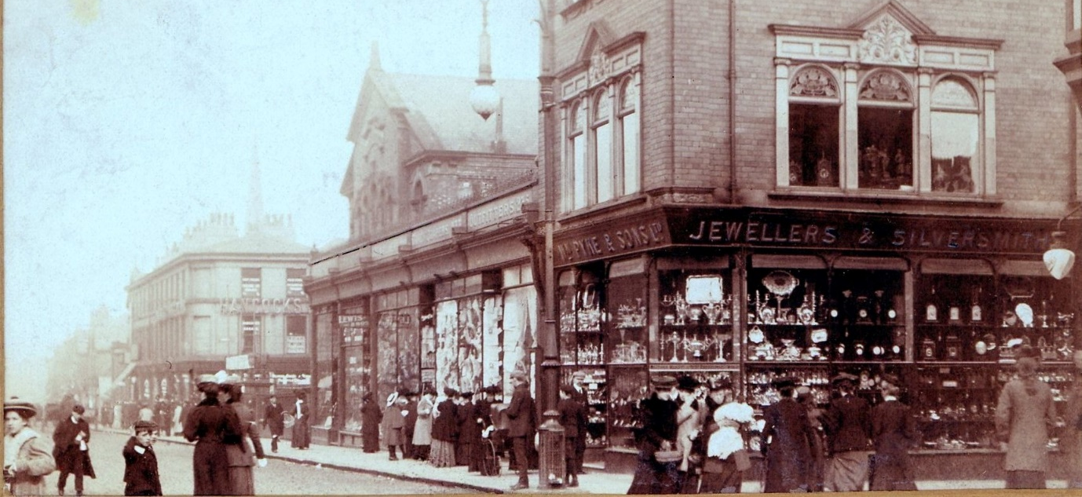
View East down Grange Road 1908 – the chapel can be seen behind Pykes the Jewellers
Reproduced with permission from the Wirral Library Service

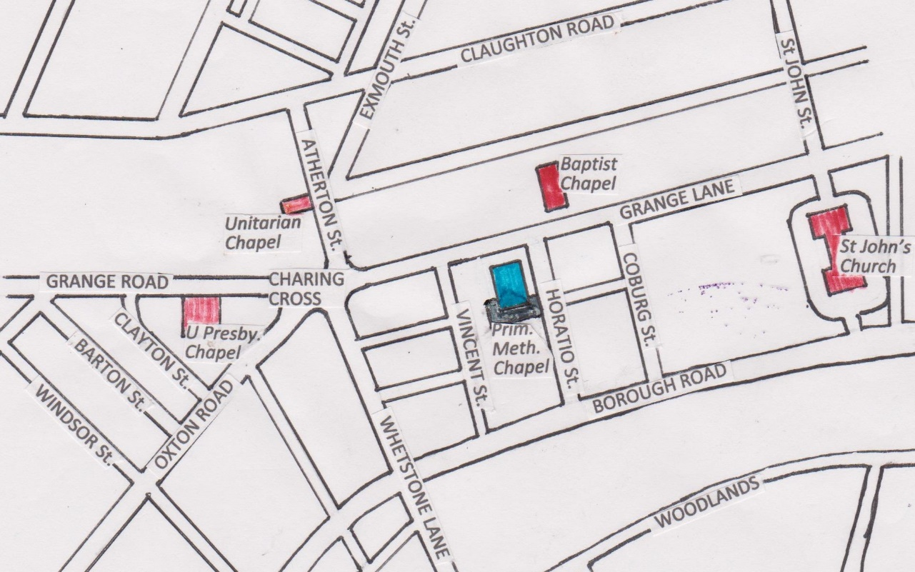
Scale 100m
Sketch Map based on an 1899 map
Grange Lane was subsequently renamed Grange Road as a continuation of Grange Road West. The site of the PM chapel is now occupied by Iceland Foods, 221-225 Grange Road, Birkenhead, CH41 2PH.

In the early 1850s there were two PM societies in Birkenhead:
- One at the west end of town centred on Beckwith Street, probably founded in the mid- to late-1840s (full description here). Its first chapel was probably built in the late 1840s and closed in the mid-1870s, and its second chapel was built in 1880 and closed in about 1930.
- The other at the east end of town, probably founded in the early 1850s (full description here). It met in the Friends Meeting House in Hemingford Street from 1854/5 and in 1858 acquired an 1837 chapel from the Welsh Calvinists in Camperdown Street. The society remained there until moving to the new Grange Lane chapel in 1870.
Initially, Beckwith Street was probably head of the Liverpool Circuit (Birkenhead Branch). In 1859 a separate Birkenhead Circuit was formed which by 1862 was headed by the Camperdown Street chapel. This leading role was then taken over by the new Grange Lane chapel in 1870.
The following main references to this chapel have been found so far:
- Camperdown Street Trustees Minutes (P. M.) Mar 1855-Jul 1868
(Cheshire Archives & Local Studies, EMS119/6/1)
This fascinating document is described in detail on the Camperdown Street page. In February 1862 there is the first mention of a ‘proposed new chapel’. Two years later the trustees decided to look for a site for a new chapel. In May 1866 they agreed that it was not advisable to enlarge Beckwith Street chapel ‘as we contemplate building a new chapel’. In September 1867 they sought ‘permission to dispose of the property now held by us in Birkenhead’ – presumably the Camperdown Street chapel – thereby raising funds for the new chapel.
- 1869 The Liverpool Mercury, 13 July
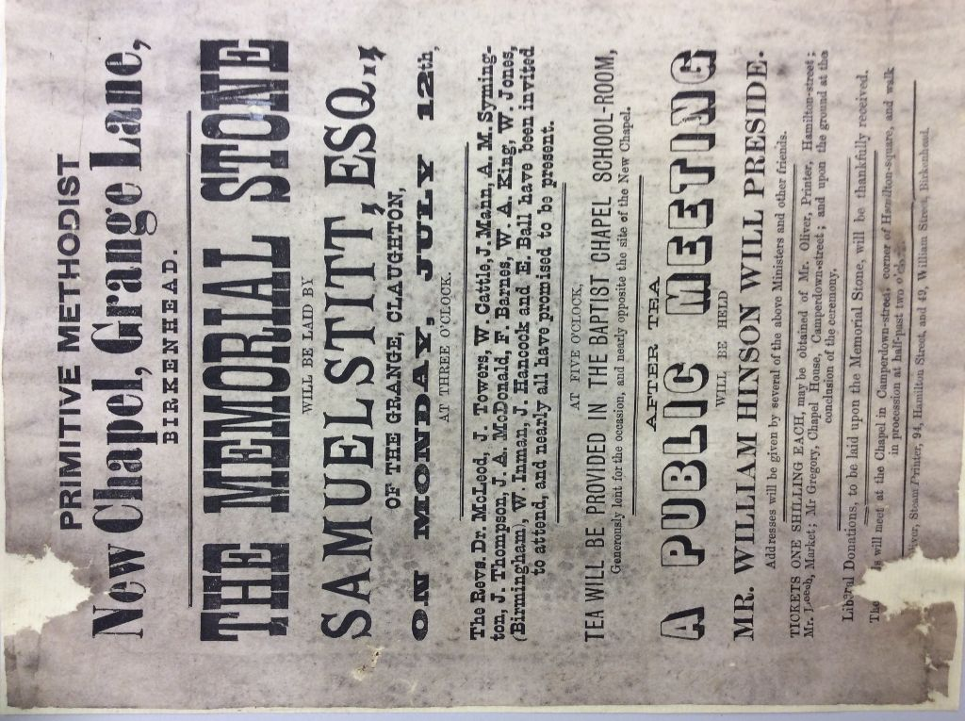
The laying of the foundation stone of the Grange Lane PM chapel:
‘NEW PRIMITIVE METHODIST CHAPEL, BIRKENHEAD.
-The Primitive Methodists in Birkenhead are extending their borders. The Birkenhead circuit has been established about ten years, and five chapels have already been opened. This accommodation, however, has been found inadequate to meet the requirements of this rapidly increasing religious body, and yesterday afternoon the foundation stone of a new chapel, calculated to afford seat room for 800 persons, was laid on a site nearly opposite the Baptist Chapel, Grange-lane, by Mr. B. Stitt, a member of the United Presbyterian Church, Claughton. The cost of the building will be nearly £3000, which it is proposed to raise by voluntary contributions. The sum of £500 has already been subscribed. The architect is Mr. John Wild, of Oldham, and the execution of the design has been entrusted to Mr. William Dickenson, builder, Seacombe. The ceremony of laying the stone was witnessed by a large number of persons, who assembled at the chapel in Camperdown-street, corner of Hamilton-road, and walked in procession to the site. …..
Mr. John Leech, the circuit steward, deposited in a cavity of the stone a bottle, containing a Primitive Methodist newspaper and almanac, a Birkenhead circuit plan, and the names of the trustees of the new chapel, of the architect and builder, and of the gentlemen who assisted in the ceremony.’
Four of the five chapels mentioned can be identified as: Lower Tranmere (1862), Liscard (before 1864), Saughall (1864) and Seacombe (1868).
- 1869: The 1869 Q3 Preaching Plan for the Birkenhead Circuit in the foundation stone (see above) and is now in the Cheshire Archives showed the following Places: Camperdown Street (by implication the head of the circuit), South Tranmere, Lower Tranmere, Beckwith Street, Poulton, Bebington, Seacombe and Saughall.
- 1869: According to a 1923 booklet, ‘Grange Road, the head of the [Birkenhead] First Circuit, was opened in 1869; it is the successor of Camperdown Street, which in its day superseded an old Friends Meeting House in Hemingford Street.’ No newspaper report of the opening of the chapel has been found.
- 1870: The report in the Builder of 16 April 1870 mentions ‘large school-rooms’.
- 1874: Morris’s Directory 1874 p. 217 shows three PM chapels in Birkenhead: Beckwith Street, Grange Lane and Queen’s Street, Lower Tranmere.
- 1876: An 1876 map shows the chapel labelled ‘Methodist Chapel (Primitive); seats for 800’.
- 1899: The Preaching Plan for the Birkenhead Circuit 1899 Q2 shows the following:
Place | Members | Society Steward | Mission Bands
Grange Road | 114 | J. Bellis, Prenton Road West | Two bands, 7 members and 8 members respectively
Mount Tabor, Tranmere | 109 | Peter Weigh, 120 Rodney Street, Tranmere | 7 members
Beckwith Street | 17 | Charles Evison, 20 Kinmel Street | 5 members
Poulton | 7 | Mrs Thomas, Thornton Common, near Neston | -
Seacombe | 7 | W. H. Miller, M.D., St Paul’s Road, Seacombe | -
Irby | 15 | Mrs Cooke, Irby | -

Although the Grange Road membership seems much lower than the chapel capacity, I have found examples where average attendance is several times the membership.
- 1902: Kelly’s Directory 1902 p. 60 describes the chapel as follows ‘Erected in 1870 at a cost of £3,750, is an edifice of brick with stone dressings, with sittings for 780 persons.’ It is then shown (page 69) as head of Birkenhead No. 1 Circuit (the circuit having been split since 1899), having services at 10.45am and 6.30 pm; the ministers were Rev. John Mayles, Rev. John J. Reeves with Rev. Thomas Bramall, supernumerary. Beckwith Street was the only other chapel listed in the circuit.
- 1906: Kelly’s Directory 1906 contains the same description of the chapel; then on page 77, the ministers were given as Rev. Thos. Kynston (supt.), Rev. Wm. Upright, Rev. John Mitchell and Rev. Thomas Bramall, supernumeraries. The other chapels in the circuit were: Beckwith Street; Brighton Street, Seacombe; and Eaton Road, West Kirby.
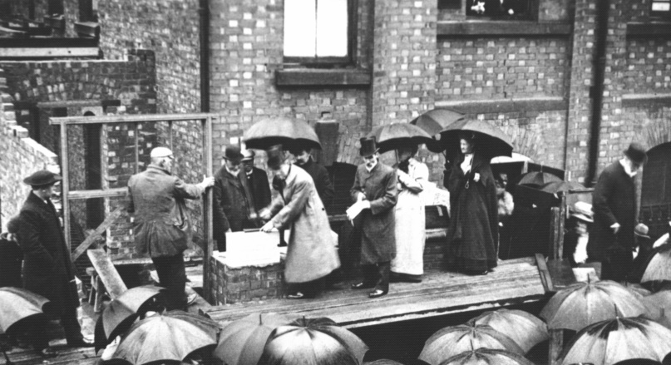
- 1908: A photograph from May 1908 shows the foundation stone being laid for a ‘Church Hall’ attached to the south of the chapel.
Reproduced with permission from the Wirral Library Service
The 1908/9 OS 25” map Cheshire XXXI.3 shows ‘Meth. Chap. (Prim.)’ scaling at 49’ frontage x 72’ deep, and the new ‘Sun. Sch.’ at the back scaling at 67’ x 28’. The Sunday School outline has been added to the sketch map above.
- Cheshire Archives & Local Studies holds the following information about this chapel:
- Ref. EMS 119/10/3-5: Birkenhead, Grange (Granger?) Road Primitive Methodist Chapel. Documents that were found under the foundation stone, to include a Preacher’s Plan, July-Oct., 1869. The Primitive Methodist Almanac, 1869, etc.
- Ref. EMS 119: Registers of christenings and marriages, minutes, accounts, collection journal and other records, 1886-1959
- Also Sunday School Minute Book 1884-1900
- Wirral Archives holds various papers and correspondence covering the period 1938-1959. (Ref Acc 1952)
These archived records indicate that the chapel had closed by 1959.
It is interesting to speculate on the early days of this society. Why, in the mid-1850s, did the society form when there were two nearby societies with chapels? Where did they worship before they built the chapel? What led them to decide to fund-raise and build such a large chapel, more than ten times the capacity of the ~100-seat chapel in Camperdown Street that it replaced? The Beckwith Street society probably vacated their first chapel in the mid-1870s; did they then move to Grange Lane for worship, and what then led them to decide to build a new chapel back in Beckwith Street in 1880. We’ll never know.

